**CSC 3101 - FALL 2016**

**Lab Assignment 6**

Please read the requirements carefully. Any missing point will result in a grade reduction. This assignment has to be submitted to your **blackboard in class** including the **Word file and *Logicly file***. Hard copy is **not accepted**.

**Question 1:** **(50)**

Write a program in Easy68K to print out “Hello World” in two lines as

*Hello*

*World*

Paste your code and screenshot in this file.

Hint: You can find out how to print string in a new line at http://www.easy68k.com/QuickStart/TrapTasks.htm

*-----------------------------------------------------------

* Title : Lab 6

* Written by : Caleb Latimer

* Date : 10/19/2016

* Description: Question 1

*-----------------------------------------------------------

ORG $1000

START: ; first instruction of program

* Put program code here

LEA MESSAGE,A1

MOVE.B #14,D0

TRAP #15

MOVE.B #9,D0

TRAP #15

SIMHALT ; halt simulator

* Put variables and constants here

CR EQU $0D

LF EQU $0A

MESSAGE DC.B 'HELLO',CR,LF

DC.B 'WORLD',0

END START ; last line of source

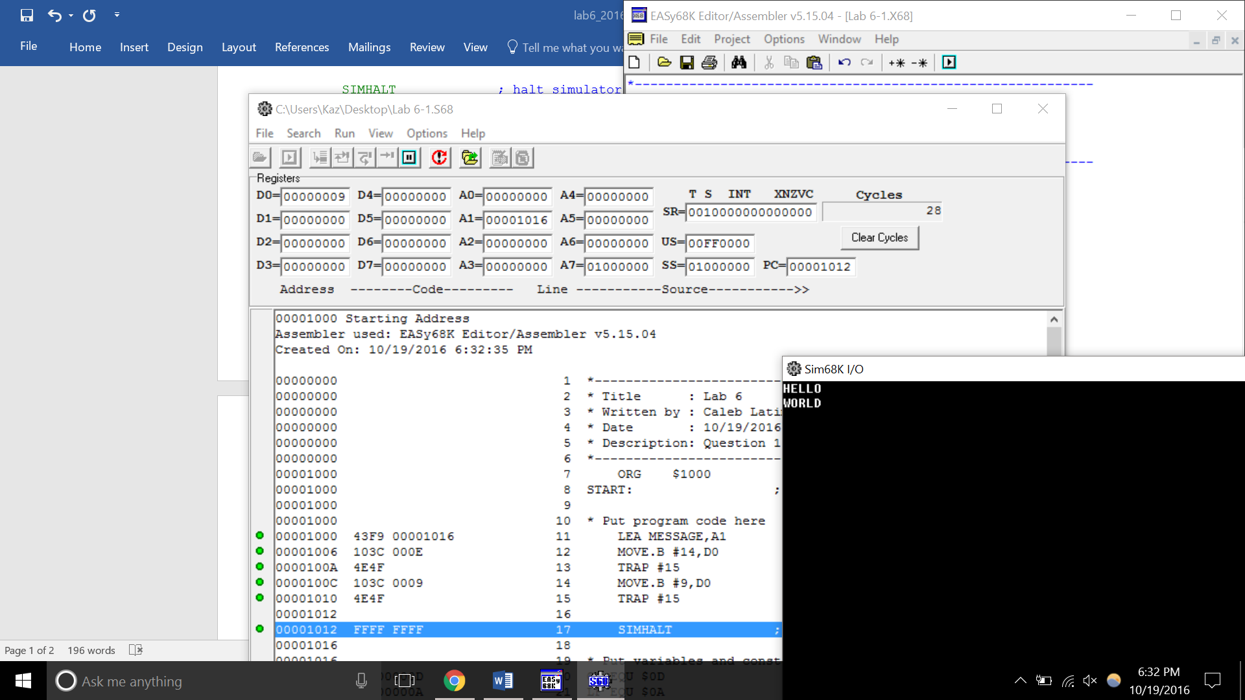

**Question 2:** **(50)**

Compute the sum of the four digits in your AccessID and print it out. Your output should be in this format:

*My AccessID is ab1234*

*The sum is 10*

Paste your code and screenshot.

*-----------------------------------------------------------

* Title : Lab 6

* Written by : Caleb Latimer

* Date : 10/19/2016

* Description: Question 2

*-----------------------------------------------------------

ORG $1000

START: ; first instruction of program

* Put program code here

MOVE.B #1,D1

ADD.B #2,D1

ADD.B #9,D1

ADD.B #7,D1

LEA MESSAGE,A1

MOVE.B #14,D0

TRAP #15

LEA MESSAGE2,A1

MOVE.B #14,D0

TRAP #15

MOVE #3,D0

TRAP #15

SIMHALT ; halt simulator

* Put variables and constants here

CR EQU $0D

LF EQU $0A

MESSAGE DC.B 'MY ACCESSID IS EJ1297',CR,LF,0

MESSAGE2 DC.B 'THE SUM IS ',0

END START ; last line of source

